REDEFINING SILICA LIMITS: AN INNOVATIVE APPROACH TO SCALING CONTROL IN HIGH-RECOVERY RO/NF SYSTEMS

BEATRIZ COLACIOPPO AND MO MALKI AND JOSHUA UTTER
American Water Chemicals
Tampa, FL

KEYWORDS: silica scaling, membrane fouling, antiscalant, reverse osmosis, nanofiltration, polymerization inhibition

ABSTRACT
Silica remains one of the most persistent and complex challenges in membrane systems. Unlike other common scales, which can be effectively controlled at supersaturated levels with modern antiscalants, silica exhibits scale-forming behavior that is difficult to control with standard inhibition approaches. As a result, systems operating with high silica concentrations often face limitations in recovery, frequent cleanings, and irreversible performance loss.
These challenges have become more pronounced as the industry strives for higher recovery rates in response to increasing water scarcity and growing demand for improved sustainability. Whether in municipal or industrial water treatment, maximizing water recovery in reverse osmosis (RO) and nanofiltration (NF) systems has become a critical objective, but one increasingly constrained by silica.
Benchtop experiments were conducted to compare the new formulation against a range of commercially available silica antiscalants, including products widely regarded as industry best performers. Testing focused on evaluating dispersion stability and polymerization rates in high-silica environments. The technology was then evaluated in both pilot and full-scale nanofiltration systems treating silica-rich groundwater, after years of persistent scaling despite the use of industry-leading silica control products.
Results showed that the novel disruptor significantly outperformed conventional technologies in suppressing silica polymerization during benchtop testing. In the field, it maintained membrane performance, reduced cleaning frequency, and enabled stable operation under conditions that had previously led to persistent scaling. Together, these findings suggest that this next-generation technology can redefine silica control expectations in high-recovery systems.

INTRODUCTION
Global water stress is driving a fundamental shift in how utilities and industries operate membrane treatment systems. With growing pressure to conserve resources, reduce brine discharge, and meet sustainability goals, many facilities are being pushed to increase recovery in reverse osmosis (RO) and nanofiltration (NF) systems. Higher recovery reduces water waste and improves system efficiency, but it also increases the risk of membrane scaling as solute concentrations in the reject stream approach or exceed saturation limits.
While modern antiscalants have enabled reliable control of most scaling species even under aggressive operating conditions, silica continues to defy conventional treatment strategies. In most high-recovery applications, it is no longer calcium or sulfate that limit recovery – it’s silica.
Silica scaling behaves fundamentally differently from crystalline scale and remains difficult to predict, prevent, or remove. In systems treating silica-rich feedwaters, recovery is often limited not by mechanical constraints, but by the inability of current chemical control strategies to address the unique challenges of silica polymerization.
This work explores the development and validation of a next-generation silica disruptor designed to overcome the limitations of conventional treatment thresholds, thereby unlocking higher recovery as a critical tool in addressing global water scarcity.
BACKGROUND
Mineral scale formation in membrane systems can occur through two distinct mechanisms: crystallization or polymerization. Crystallization results in the development of well-defined minerals such as gypsum and calcite, whereas polymerization is unique for the formation of amorphous solids, such as silica scale. The rate of silica scale formation is a function of both the thermodynamic and kinetic properties of silica, and this process isn’t only difficult to predict but also to inhibit (Tong, 2025).
Silica is naturally present in most water sources in the form of monomeric silicic acid [Si(OH)4], a weakly ionized species that remains relatively soluble and stable at low concentrations. When concentrations exceed approximately 100 ppm as SiO2, polymerization typically begins, with the rate and extent influenced by factors such as pH, temperature, ionic strength, and the presence of multivalent cations such as calcium. This process leads to the formation of small colloidal oligomers, which can grow into larger polymeric structures and eventually form amorphous silica gel that deposits on membrane surfaces and continues to accumulate over time.
Compared to gypsum and calcium carbonate, for example, silica scaling is more difficult to manage due to its unique formation mechanism, polymerization, which modern antiscalants struggle to effectively inhibit. Phosphonate- and carboxylic-based inhibitors have demonstrated strong performance in controlling crystallization-driven scale formation during membrane desalination. However, efforts to develop antiscalants targeting silica polymerization remain relatively scarce. Most of the available studies on this topic rely on static testing conditions and do not incorporate membrane systems, limiting their applicability in real-world scenarios.
Even the most advanced commercially available silica antiscalants today typically claim maximum inhibition thresholds of approximately 300 ppm SiO2 in the reject stream. However, performance can often deteriorate in systems well below this level, particularly under conditions that accelerate silica polymerization, potentially leading to severe irreversible membrane scaling and increased cleaning frequency. To address these limitations, a novel antiscalant was developed to directly inhibit the polymerization process and extend silica tolerance beyond current industry thresholds. Its performance was first evaluated through a controlled benchtop study designed to simulate aggressive scaling conditions known to promote rapid silica polymerization, providing a stringent test of the antiscalant’s effectiveness.
BENCHTOP EVALUATION OF SILICA CONTROL
EXPERIMENTAL SETUP - Each antiscalant formulation, both conventional and those incorporating the novel disruptor, was evaluated in a controlled benchtop setup designed to simulate conditions that promote rapid silica polymerization. The test solution consisted of 25 ppm of pre-sonicated colloidal silica (~100 nm) and 500 ppm of reactive silica. Polymerization was triggered by introducing a separate solution containing 1000 ppm of calcium, which reduces silica solubility and increases the polymerization rate. This mixing was carried out in the presence of the antiscalant being tested to assess its effect on the silica polymerization rate. All solutions were pre-aged for one week prior to testing.
Each antiscalant was tested at two dosage levels: 6.25 ppm and 12.5 ppm. As performance trends were consistent across both concentrations, only the results from the 12.5 ppm tests are presented here. The complete dataset, including the 6.25 ppm results, is available upon request.
Silica polymerization and colloid growth were monitored using nanoparticle tracking analysis (NTA) at time intervals of 0, 1, and 2 hours. The percentage of particles smaller than 200 nm was used as an indicator of dispersion stability and polymerization suppression. An increasing proportion of particles larger than 200 nm over time was interpreted as evidence of particle growth due to silica polymerization and agglomeration. It was assumed that more effective antiscalants would maintain a higher percentage of sub-200 nm particles by limiting polymerization.
RESULTS AND INTERPRETATION - As illustrated in Figure 1, which plots the percentage of sub-200 nm particles over time for the different antiscalants, all formulations containing the novel silica disruptor (Si products, represented by solid lines) began with a significantly higher percentage of sub-200 nm particles compared to conventional antiscalants (dashed lines). While both groups showed declines over the two-hour period, the Si products consistently maintained a much higher proportion of small particles, indicating significantly greater resistance to colloidal growth and silica polymerization. These results underscore the clear performance gap between the two product groups, with the Si products demonstrating more effective and sustained inhibition of silica aggregation under identical polymerization-prone conditions.
Figure 1:
Percentage of silica particles <200 nm over a 2-hour period at 12.5 ppm antiscalant dosage. Solid lines represent formulations containing the novel silica disruptor (Si Products), while dashed lines represent conventional products.
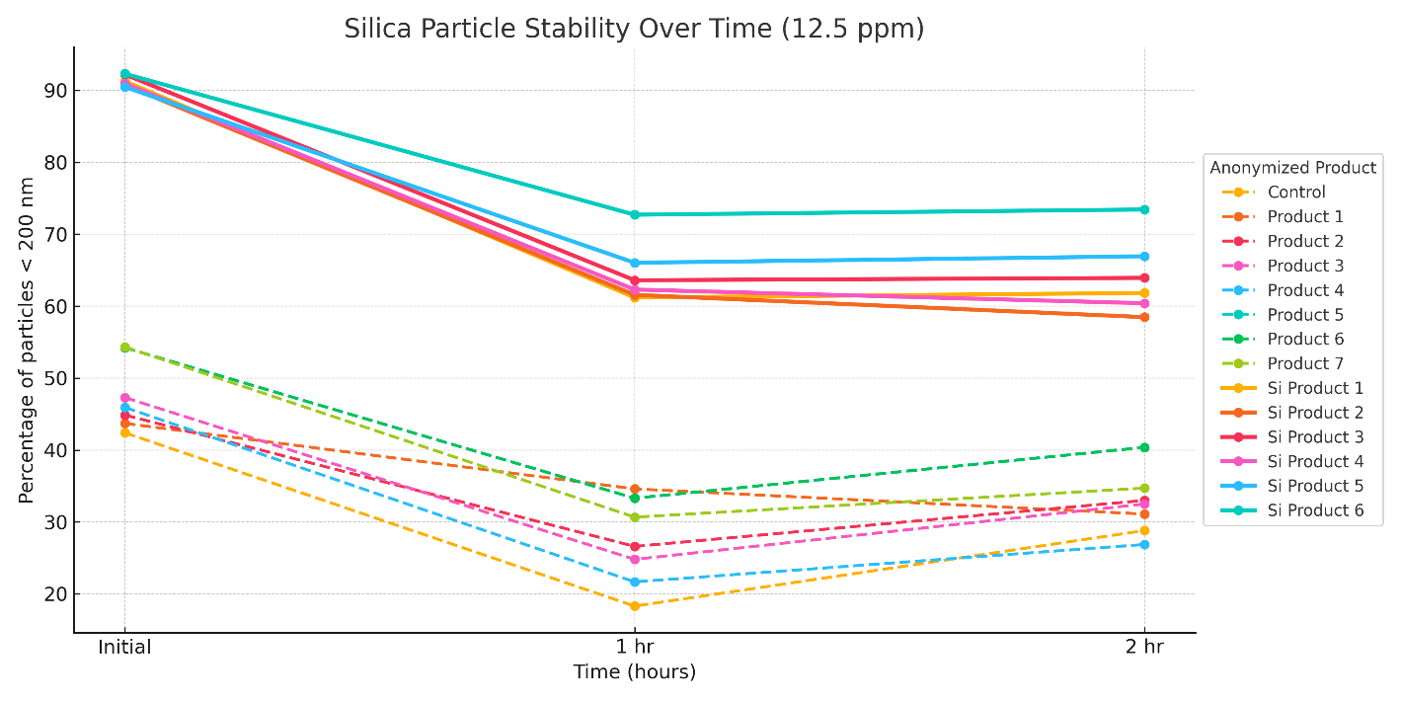
As shown in Figure 2, which compares initial and 2-hour particle size distributions for each product, Si products retained a much higher percentage of particles under 200 nm. Notably, some conventional antiscalants performed no better than the control test solution, which contained no polymerization inhibitor at all.
“Product 4,” for example, exhibited an initial sub-200 nm particle percentage of 45.9%, which dropped to 27% after two hours. Even the best-performing conventional product showed a final sub-200 nm percentage of only 40%. In contrast, Pureflux® Si “Si Product 6,” the top-performing formulation containing the silica disruptor
, maintained a significantly higher proportion of small particles throughout the test. It maintained 92% of particles under 200 nm initially, and after two hours, over 73% remained below that threshold, indicating strong suppression of colloidal growth and effective inhibition of silica polymerization.
Figure 2:
Sub-200 nm silica particle retention at 0 and 2 hours for each product tested at 12.5 ppm dosage. Bars represent the percentage of particles <200 nm initially (light bars) and after 2 hours (dark bars). Products containing the novel silica disruptor (Si Products) maintained significantly higher retention of sub-200 nm particles, indicating more effective suppression of polymerized silica growth compared to conventional formulations.
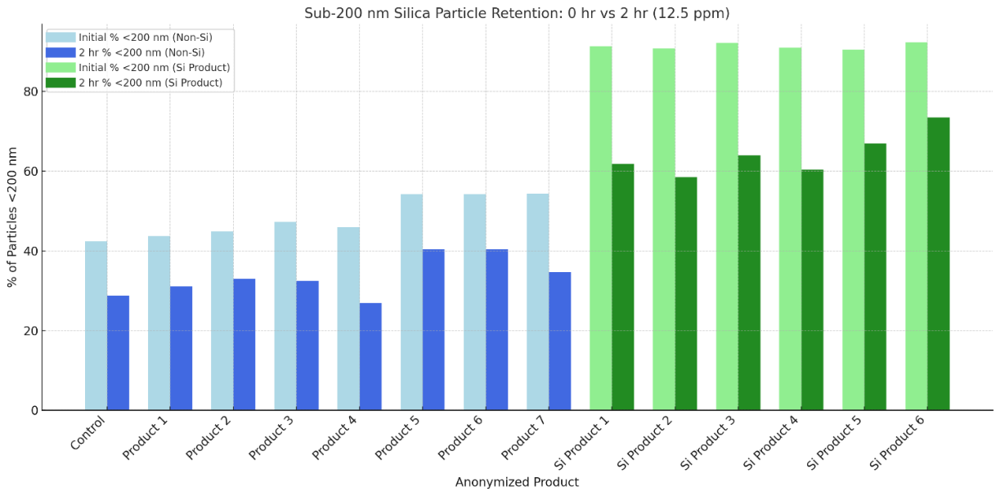
Among the Si formulations, “Si Product 6” stood out with the highest overall retention and the most consistent stability over time. This suggests it may offer the strongest kinetic resistance to silica aggregation and serves as a promising candidate for further validation at pilot and full-scale systems, as described in the following sections.
FIELD EVALUATION OF SILICA CONTROL
FULL-SCALE OPERATIONAL HISTORY - The performance limitations of conventional silica-specific antiscalants were clearly demonstrated at a municipal nanofiltration facility in Florida that consistently struggled to control silica scaling, despite the use of leading competitor products, including both antiscalants and cleaning chemicals specifically formulated for silica mitigation.
Commissioned in early 2018, the facility was designed with an 8:4 (7M) array to treat groundwater from three wells drawing from the Sandstone aquifer, a source known for its relatively high silica content compared to other Florida aquifers. Although the system was originally designed to operate at 85% recovery, it was limited to 80% due to elevated feedwater silica concentrations (60–70 ppm as SiO2), resulting in a projected concentrate concentration of approximately 290 ppm SiO2, well beyond the solubility threshold and posing a significant risk of scaling, even at the suppressed recovery.
Our testing also indicated the presence of approximately 6 ppm colloidal silica in the feedwater, prior to any concentration. While colloidal silica is difficult to quantify with high precision, the system’s high fouling rate supports the conclusion that it was present at considerable levels. Detailed water quality data and scaling potential projections are provided in Appendix A.
In 2019, approximately one year after commissioning, the plant observed a decline in performance and performed a second-stage tail element autopsy. The membrane exhibited a permeability 14% lower than the manufacturer’s quality control test. Visual inspection revealed a thin layer of foulant consistent with early-stage silica scale, confirming that polymerized silica was already beginning to accumulate on the membrane surface despite chemical treatment efforts.
Figure 3:
SEM/EDS analysis of the membrane surface, confirming the presence of amorphous silica scale. Left: 80× magnification. Right: 11,000× magnification.
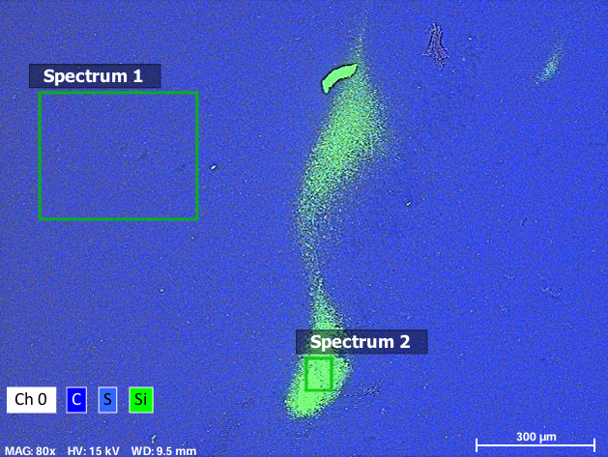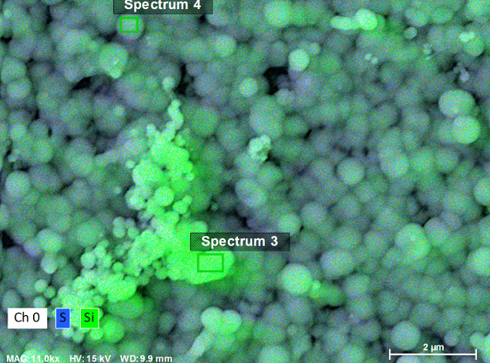
In response to the autopsy findings, the plant’s previous chemical supplier revised its recommendation to a silica-targeted antiscalant and introduced a CIP protocol specifically formulated to remove silica scale. Beginning in 2021, the facility also implemented routine data normalization to better track membrane performance trends, as shown in Figure 4. Over time, a steady decline in second-stage permeability was observed, eventually exceeding the CIP threshold, defined as a 15% drop in specific flux. Despite multiple cleanings, membrane performance never fully recovered to pre-cleaning levels, suggesting that silica scaling was not being effectively mitigated. The antiscalant in use continued to struggle with polymerization control, allowing further performance decline over time.
Figure 4:
Temperature-corrected permeability for Stage 2 of the full-scale system from early 2021 through November 2024. This period reflects the plant’s normalized performance tracking over time. The green line marks the effective CIP and transition to Product 6 in August 2024, which fully restored permeability. However, a gradual decline followed, attributed to the high silica concentration in the reject stream. Data beyond this point is discussed separately.
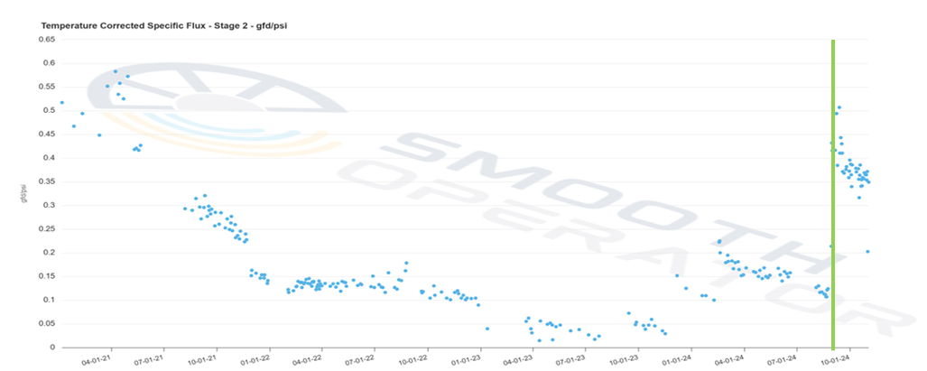
The frequency of CIPs continued to increase over time, and by June 2024, one of the trains experienced a complete shutdown due to a severe loss in permeability. This prompted the facility to perform another membrane autopsy to further investigate the issue and explore alternative approaches to address the ongoing silica challenges. The autopsy was conducted on a second-stage tail element from the same train, and position, that had previously been autopsied and discussed earlier in this paper.
In this case, now four years after the initial autopsy, the element was so severely fouled that performance testing could not be conducted. Excessive differential pressure prevented achieving the required flow rate without risking membrane damage. Visual inspection revealed heavy white deposits on the feed spacers and a dense, glassy layer on the membrane surface, both indicative of advanced silica fouling.
Figure 5:
Visual inspection of the unraveled element. Left: Membrane surface covered with a dense, glass-like layer. Right: Feed spacer coated with a white powdery deposit, both consistent with advanced silica scaling.
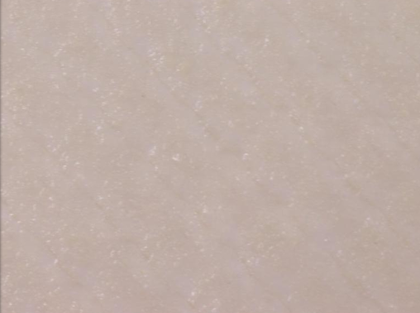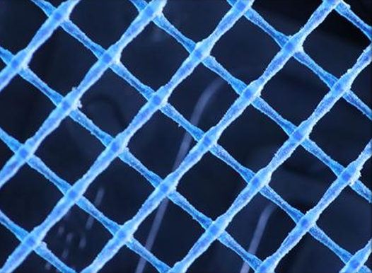

SEM imaging confirmed the presence of thick, layered amorphous silica, consistent with multiple years of unchecked polymerization. Minor peppered deposits of calcium carbonate were also observed on the surface. These trace deposits likely resulted from prior cleaning practices, which involved high-pH cleaning solutions prepared with permeate containing elevated hardness levels and were not consistently followed by a low-pH rinse. However, the calcium carbonate was minimal and not considered a contributing factor to the membrane’s performance loss. The primary foulant remained amorphous silica, which the CIP chemicals in use were unable to remove due to the scale’s density and severity, highlighting the need for a more targeted cleaning approach.
Figure 6:
SEM-EDS SEM/EDS analysis of the membrane surface. Images show a thick layer of amorphous silica (green, Si) and scattered crystalline calcium carbonate deposits (pink, Ca) on the membrane surface. The right image highlights the layered structure of the silica scale, indicating it had formed over an extended period of time.
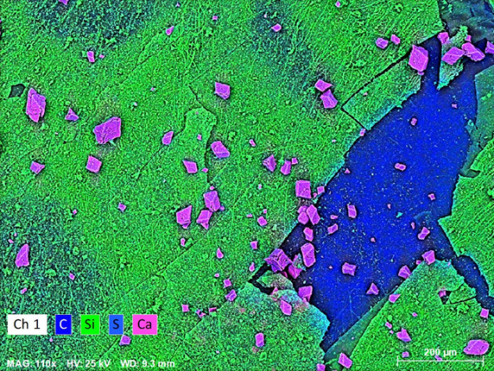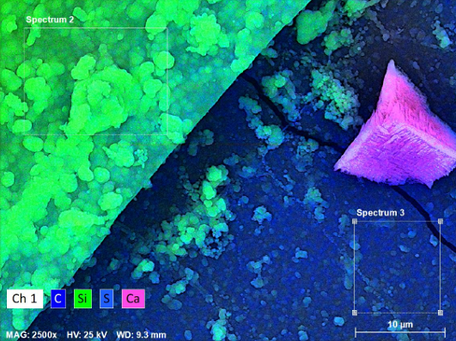
Figure 7:
SEM/EDS cross-section of a membrane element showing a thick, layered deposit of amorphous silica (green, Si) on the membrane surface. The right-hand image highlights the scale height. The severe scale buildup is consistent with prolonged polymerization and correlates with the high differential pressure (dP) observed during system operation.
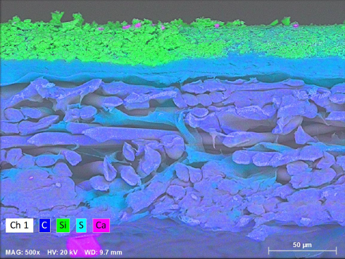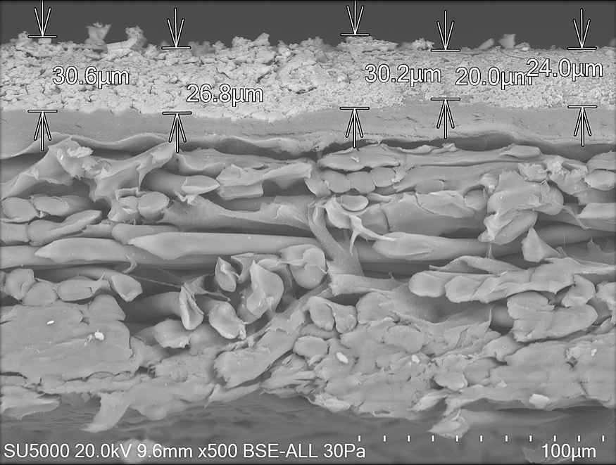
Following this, the plant changed antiscalants once more – this time switching to Product 6, the top-performing non-Si formulation identified during benchtop testing (as shown in Figures 1 and 2). With the addition of an improved CIP protocol specifically tailored for severe silica scaling, the system achieved full performance recovery, something the plant had not been able to accomplish since 2021, as shown in Figure 4. However, due to the extremely high silica concentration in the reject stream, membrane performance continued to decline gradually. The system typically reached the CIP threshold within approximately three months. While overall stability and performance were significantly improved compared to that of the previous product, silica scaling remained a persistent operational challenge for the plant.
PILOT EVALUATION - To evaluate an alternative solution for improved control of silica scale formation using the novel disruptor technology, a pilot system was installed onsite in early 2025. The pilot drew directly from the same raw water line as the main plant and used Pureflux® Si (“Si Product 6”), the top-performing formulation from the benchtop tests. The single-stage system was configured with a recycle loop to achieve the plant’s target recovery, initially set at 85%. A more aggressive condition than the main plant’s current recovery, and particularly challenging for silica control. After several months of stable operation, the recovery was further increased to 87%.
At this recovery, the projected silica concentration in the reject stream reached approximately 400 ppm as SiO₂, an extremely challenging level that exceeds the inhibitory limits of all conventional silica-specific antiscalants. Additionally, the recycle configuration continuously returned already formed colloidal silica from the concentrate to the system inlet, which was believed to further increase the scaling potential, as the polymerization process had already begun. To closely mimic full-scale operations, the pilot was operated on the same schedule as the main plant, including flush cycles and downtime. Detailed water quality and scaling potential projections are provided in Appendix B.
To closely monitor any early signs of scaling, the pilot system was configured to track the permeability of the last element independently. This setup enabled early and accurate detection of performance deviations at the point of highest scaling potential.
As shown in Figure 8, the normalized permeate flow of the last element remained stable over an eleven-month period, with no measurable decline. Notably, no CIP was performed during the pilot runtime. Despite operating at a higher recovery than the main plant, the pilot demonstrated more than double the CIP interval, highlighting the enhanced stability of the system using the novel silica polymerization disruption technology.
Figure 8:
Last element normalized permeate flow during pilot operation with the novel silica disruptor, from January to November 2025. System performance remained stable throughout the test period, with no CIP-triggering decline. The increase observed around April was due to calibration of instrumentation and not a performance-related change. No cleanings were performed during this time, confirming the effectiveness of the disruptor under aggressive, high-recovery conditions.
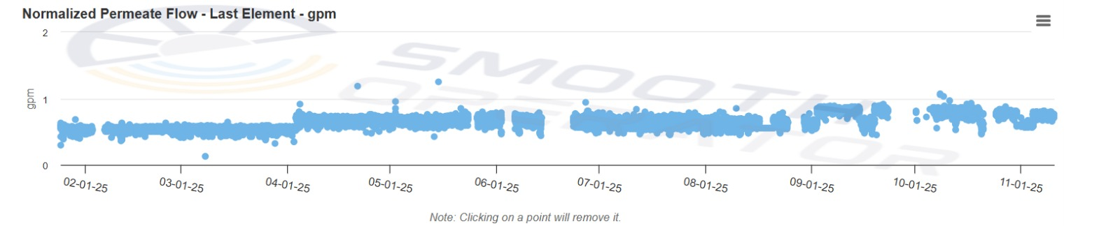
An autopsy of the last element was conducted after several months of operation. No silica deposits were observed on the membrane surface, even under 4000x magnification, confirming complete inhibition of polymerized silica formation under these highly challenging conditions.
Figure 9:
SEM/EDS analysis of a membrane element after pilot testing with the novel silica diruptor. Left: 60× magnification. Right: 4,000× magnification. No silica (Si) was detected, confirming the absence of scale formation on the membrane surface.
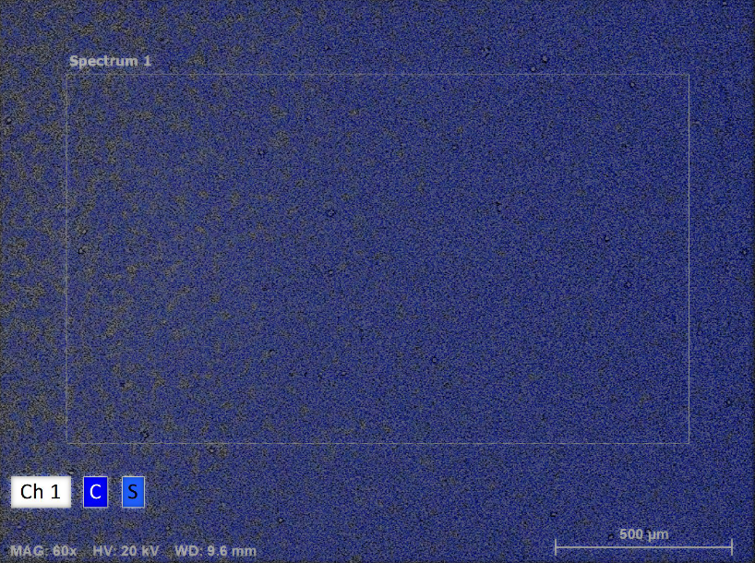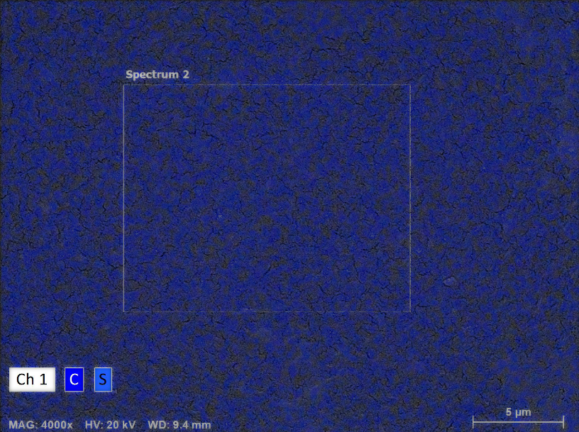
Following the successful pilot results, the full-scale plant transitioned to the novel silica disruptor in June 2024. After over six months of operation, normalized performance data for the 2nd stage (Figure 10) showed minimal decline in permeability. However, this is the first time in the plant’s history that they have been able to operate longer than 3 months without crossing the CIP line (15% decline in normalized permeate flow). The plant continues to monitor system performance and is currently evaluating a stepwise increase in recovery back to its original design value of 85%. In parallel, pilot testing remains ongoing to assess the feasibility of pushing recovery beyond 87%.
Figure 10:
Temperature-corrected permeability for Stage 2 of the full-scale system from December 2024 through November 2025. The green line indicates the effective CIP and transition to Product 6, which fully restored permeability, but a noticeable decline in performance was still observed. The green line marks the switch to Si product 6. Since that transition, system performance has remained stable with no CIP-triggering decline in permeability. Data collection is ongoing to continue monitoring long-term performance
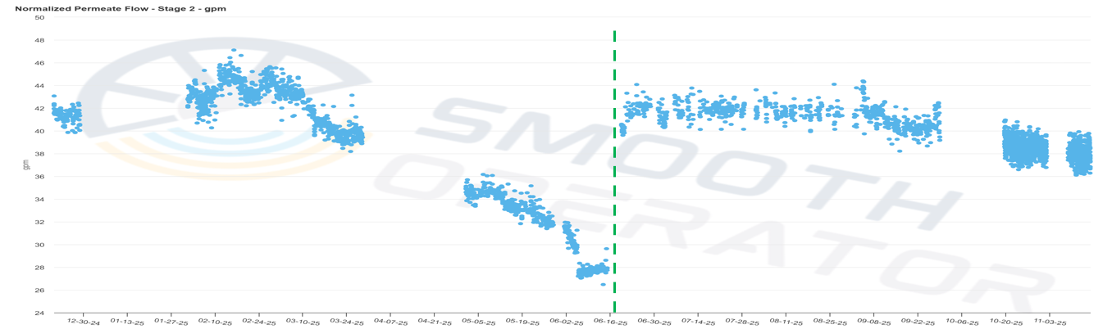

These field results reinforce the findings from benchtop testing, confirming that the novel disruptor effectively inhibits polymerized silica scale formation, even under aggressive operating conditions. This technology not only restored system performance but also opened the door to improved operational efficiency through reduced CIP frequency and the potential for higher recovery.
DISCUSSION
Benchtop testing clearly demonstrated the limitations of conventional silica inhibitors under simulated high-recovery conditions. While existing products struggled to prevent silica polymerization, the novel disruptor evaluated in this study provided significantly better inhibition over a two-hour period under identical, highly supersaturated conditions.
These findings were validated by full-scale operational data from a Florida municipal nanofiltration facility with a long history of silica scaling. Despite using a competing silica-specific antiscalant and implementing targeted CIP protocols, the plant continued to experience declining permeability, frequent cleanings, and ultimately, complete train shutdowns. The inability to restore performance through repeated CIPs underscored the difficulty of removing established silica scale and reinforced the importance of prevention.
The novel disruptor was later piloted under more aggressive conditions than the full-scale system, including higher recovery and continuous concentrate recycling, yet maintained stable performance over seven months, with no detectable scaling and no CIPs performed. A clean membrane autopsy confirmed complete inhibition of silica deposition. Following the pilot’s success, the full-scale plant transitioned to the novel disruptor in mid-2025, resulting in stabilization of membrane performance. As of this writing, no CIP-triggering decline has occurred.
The strong alignment between benchtop, pilot, and full-scale results confirms the robustness of the disruptor and its suitability for full-scale implementation. These findings demonstrate that effective silica control requires a shift away from traditional approaches toward targeted polymerization inhibition. The novel disruptor represents a meaningful advancement in silica scale management, enabling higher recovery, reduced operational costs, and more sustainable long-term membrane performance.
While results to date are promising, continued monitoring is underway to evaluate long-term performance under varying conditions. Future work will focus on expanding field validation across different membrane types and water sources, including brackish and industrial applications, as well as on optimizing dosage strategies to maximize recovery.
CONCLUSION
As membrane systems are increasingly pushed to operate at higher recoveries for sustainability and cost-effectiveness, the need for reliable silica control has become more urgent. Unlike conventional scales, silica fouling arises from a fundamentally different mechanism, polymerization rather than crystallization, rendering traditional control strategies inadequate.
This study demonstrated that a novel silica disruptor, engineered to interfere with polymerization, can effectively prevent silica scaling under aggressive operating conditions. Both benchtop and full-scale field evaluations confirmed that the disruptor not only stabilized system performance where other products had failed, but also enabled higher recovery at a facility that had consistently struggled with silica fouling, despite multiple prior attempts using silica-targeted approaches.
These findings represent a significant advancement in silica management for RO and NF systems. They offer a practical path forward in addressing one of the industry’s most persistent barriers to high-recovery operation, enabling more resilient and sustainable membrane treatment solutions.

REFERENCES
Tong, T.; Gao, M.; Wu, M.; Zhou, Y.; Zhang, H.; Mi, B. A tale of two minerals: contrasting gypsum and silica scaling in membrane desalination. Frontiers of Environmental Science & Engineering. 19,3 (2025) https://doi.org/10.1007/s11783-025-1923-9

Appendix A:
Full-Scale System: Water Quality and Scaling Potential Projection at 80% Recovery
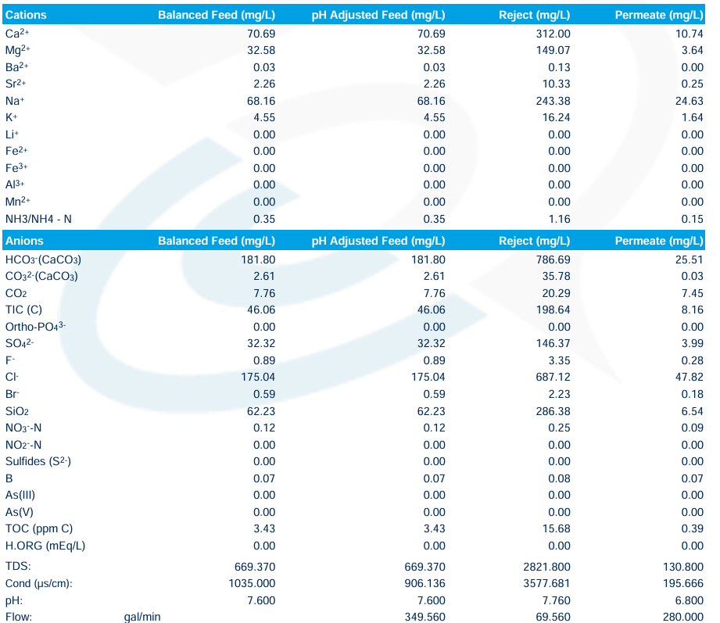
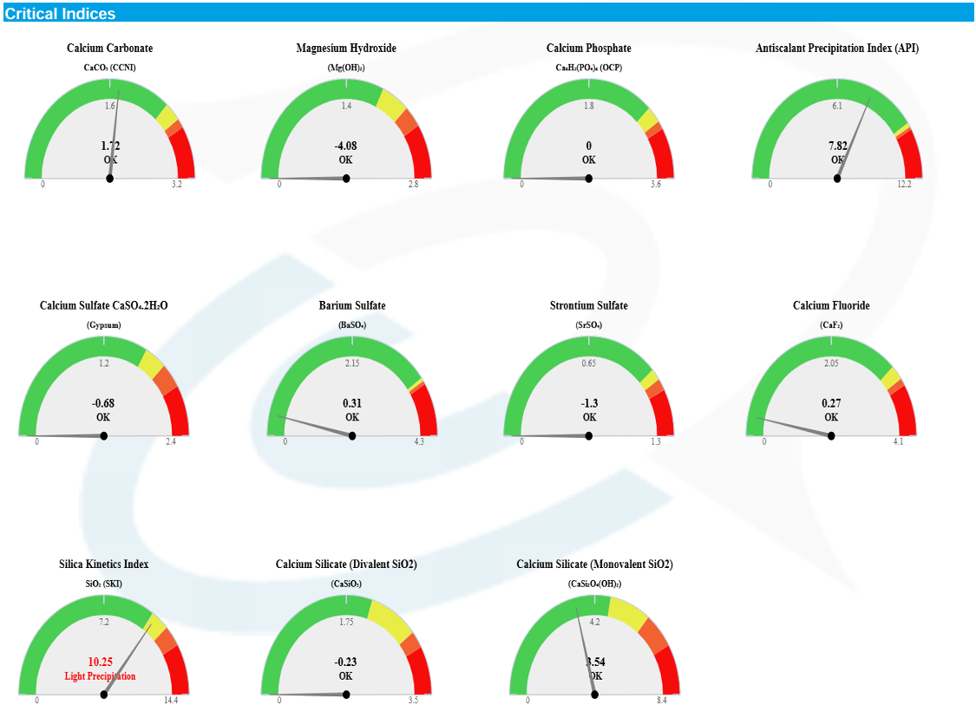

Appendix B:
Pilot System: Water Quality and Scaling Potential Projection at 87% Recovery
